**Campus Model Project Log**

24/09/18

First meeting with Stuart, clarifying the project, it is intended to be a model of the campus which will then be visible on google maps. The model should resemble the shapes of the buildings and could be rendered with pictures of the buildings, doesn’t have to be exact. The use of it will be that a chunk of the campus isn’t on google street view due to being pathways and areas cars cannot access. For extra technical aspects it could be made so that next to the map / model in a browser, there would be two drop downs, one to select where you are, and one to select where you are going and the map / model will give directions, this could be the quickest route, the best route, or the general route most people take for whatever reason.

This could then be advanced to make it mobile friendly, it could populate the where from field (as visitors or new people may not know which building they are at) and it can use the mobiles GPS to auto-populate the where from field. I would be interested in making this section happen, however will have to be listed as desirable just in case of time restraints.

Initially need to now research how to model over google maps using google API, and what modelling software needs to be used to make it, for instance SketchUp (which I believe is a google product) or if any product can be used, and how it can actually be done, and find some examples of it being used as there should be some out there.

The requirements and design can be made up using the MSCW model, e.g. the project Must have, Should have, Could have and Would have had, this can be used to make a list of what is essential requirements (2 or 3 bullet points) and then what is desirable.

Must remember to keep notes of any dead ends in the project or attempts that do not lead anywhere, as in the final dissertation even failed attempts are best to be acknowledged rather than showing no attempts. It isn’t just about getting a pristine final product (although it should be as good as it can be) but it should show that things have been thought through, attempted, and that it could be extended in the future with more time.

25/09/18

These two examples aren’t exactly what I had intended for the project, however they are good examples of using google maps to create 3D models, albeit in a slightly different manner:

<http://johndyer.name/drawing-3d-objects-and-building-on-google-maps/>

This (slightly outdated in that some links no longer work) example uses google API and the use of polygons to create the effect of 3D models overlaying google maps, it includes example code used in making the project.

<http://googlemapsmania.blogspot.com/2013/02/creating-3d-buildings-with-google-maps.html>

This references the above project, but differs slightly in how it tackles different viewing angles, it is intended to be viewed from googles 45degree imagery, but instead uses 4 different polygons for each building and switches based on an if else. May not be as efficient as the first method.

A potential snag:

<https://productforums.google.com/forum/#!topic/maps/D_IEdmLVY8U>

According to this, SketchUp is a legacy google produce that has since been sold. Need to research further but it apparently possible to still use it and overlay 3D models but not for the public to view.

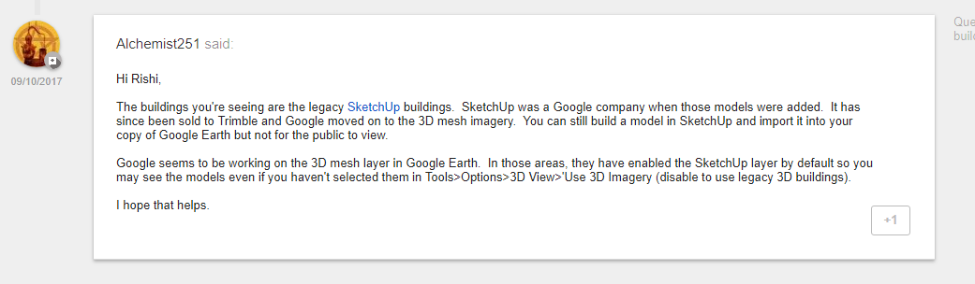

<https://groups.google.com/forum/#!msg/3dwh/epXUQA2bJ2s/pw7G8E6wtZ4J>

<https://productforums.google.com/forum/#!topic/maps/JlPLBDE4UTk>

27/09/18

Posted a question on google forum to clarify if the project is still feasible:

<https://productforums.google.com/forum/#!topic/maps/JKuSuRxODP8;context-place=forum/maps>

The below link shows that google “Overlays” have to be specific file types, which are all image files and not KML files which are produced from google sketchup:

<https://productforums.google.com/forum/#!topic/gec-collected-google-earth-wisdom/Xy9JNNz7Jhg>

Viewing your model in Google Earth:

<https://help.sketchup.com/en/sketchup/viewing-your-model-google-earth>

01/10/18

3D model rendering in browser using javascript:

<https://github.com/hujiulong/vue-3d-model>

Example of 3D interactive map:

<https://mapme.com/?utm_campaign=vrl&utm_source&utm_medium=crstory>

Met Cathedral 3D:

<https://story.mapme.com/14049bfd-a81c-4a5f-8936-93d6be146ac0/section/df3c1423-4b7b-44a3-ba6c-9e3a776b6bc1/details>

Saving a section of Google maps as an image to use as the “base” of the model:

<https://support.google.com/earth/answer/148146?hl=en>

The main idea I can see working for this project now, as google maps API does not support 3D, is to make something similar to the above mapme.com 3d modelling, in that I would use an image of the campus map as the floor, then create the models of the buildings and if possible in an engine put the models on the map, the main use of the model being to make it interactive, so you can view it from any angle without distorting, as per the mapme.com example. Then possibly making my own route-making for directions.

OR

Use something like below, make the whole model incorporate the buildings and the floor with streets, and render it in the browser:

<https://manu.ninja/webgl-3d-model-viewer-using-three-js/>

Then if the user wants directions, switch to a birdseye view and give a map with directions, possibly switching to google maps, then have a 3D view button to switch back to the model.

Example use of Three.js:

<https://threejs.org/examples/?q=vr#webgl_loader_vrml>

<https://sketchfab.com/>

This site can be used to upload 3D models to, and then it gives you code snippets to embed the model into a website. So could sign up, upload the 3D campus model and then use it to embed onto a website.

08/10/16

Potentially learn unity 3D engine and import the 3D model of the campus to that:

<https://blender.stackexchange.com/questions/19443/how-to-create-a-3d-model-of-an-object-and-then-put-it-on-the-internet-in-a-3d-vi>

specifically the second answer:

Yes, it is possible and it doesn't cost a lot. I recommend using Unity3D 5. Unity 3D is a game engine that can run on almost any platform. It can also run on any web browser if you install the Unity plugin.

If the user doesn't have the Unity plugin installed, it will ask the user to install it.

With the latest Unity3D 5 released, it can run anything on Website without Plugin. I think that Unity is the best way to do this. It uses the new web technology called "WebGL" to render 3D Objects, instead of its plugin. WebGl is supported everywhere.

Short answer:

1) Model your product in using Blender. Then [BAKE](http://www.blenderguru.com/tutorials/introduction-baking-cycles/#.VH3h4JUtDX4) your 3D model.

2) Install Unity 5 and import your model. Add a rotating C# script to it that detects mouse input and rotates your model.

3) Build the project as [WebGl(Preview)](http://blogs.unity3d.com/2014/10/14/first-unity-game-in-webgl-owlchemy-labs-conversion-of-aaaaa-to-asm-js/) format and you are good to go.

License: Unity is free as long as your company make < 100,000 every year. If you make bigger than that, you are required to buy a Unity license which cost only $1500. Its worth it.

For the script I mentioned in #2, You can just Google "Unity Rotate 3D Object with Mouse". You will find many scripts.

20 Minutes of Unity3D tutorial for your team should be fine t o accomplish this.

Routing algorithm discussion:

<https://stackoverflow.com/questions/430142/what-algorithms-compute-directions-from-point-a-to-point-b-on-a-map>

How to embed a unity project into a webpage:

<https://www.youtube.com/watch?v=K52l9P19_2o>

Idea on route highlighting:

Use nodes at intersections of the roads to highlight sections of the road objects, rather than the whole road, between each node could have a value for that distance which could be used in the search algorithm.

<https://www.liverpool.ac.uk/files/docs/maps/liverpool-university-campus-map.pdf>

Use campus map as reference, as it appears to be to scale, to be used for layout, road mapping, and a grid of building locations.